2023-24
Music Scholarship Program
Application Package

Deadline for Application is February 15, 2024

Coastal Concerts
Music Scholarship Program

About Coastal Concerts
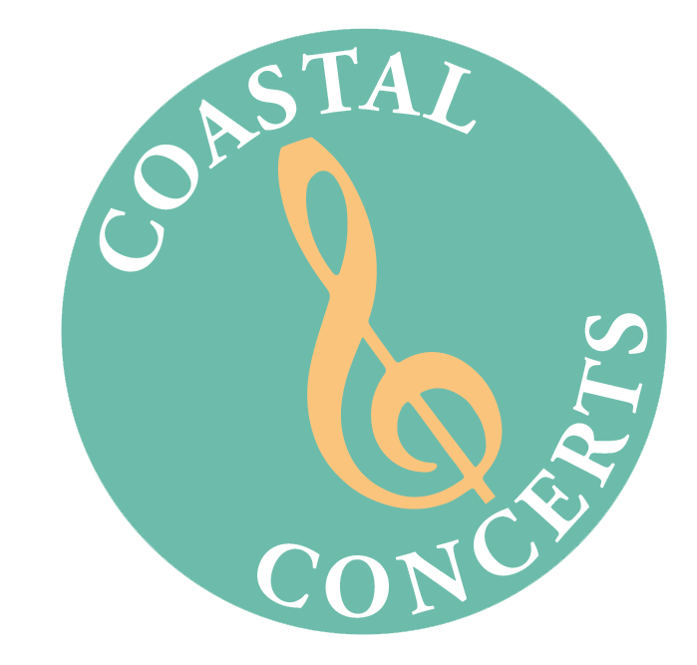
Coastal Concerts, Inc., a non-profit organization located in Lewes, Delaware, is dedicated to enrichment through classical music. Its mission is to promote classical music appreciation through live concerts, outreach, and educational activities to make fine music accessible, enjoyable and understandable for members of the community. As part of its Outreach Program, the organization sponsors an annual Scholarship Competition for musically talented Middle and High School students. From its inception in 2002, this program has awarded nearly $52,470 in scholarship monies to 61 deserving students.

General Scholarship Information and Guidelines

- Coastal Concerts may award scholarships of up to $1,500 each to High School students, and up to $1,000 each to Middle School students residing in the Delmarva Peninsula.

- At least one scholarship per year is available for a Sussex County Student.

- All middle and high school students in the Delmarva area are encouraged to apply for this annual award; however, students will not be awarded a scholarship in back-to-back years if playing the same instrument. However, winners are encouraged to apply each year if playing a different instrument. In this case, they WILL BE ELIGIBLE TO WIN BACK-TO-BACK SCHOLARSHIPS.

- Students will be competing only against those in their own age group.

- The written portion of the submission (essay, resume, etc.) is worth 25% of the score with the actual music performance being 75% of the total, which will include a live audition in addition to a YouTube video submission.

- Scholarships may be used for music camps, university courses, instrument purchase/repair, or music lessons.

- The scholarship application period runs from November 15, 2023, to February 15, 2024.

- THERE IS A $25.00 APPLICATION FEE TO HELP OFFSET ANY ADMINISTRATIVE COSTS.

- Applications will be evaluated by March 1, with auditions held later in the month.
(tentatively scheduled at the Music School of Delaware in Milford and/or Wilmington).

- Awards will be announced shortly thereafter.

Scholarship Application Requirements

- Completed Music Scholarship Application (form attached).

- Please note that a $25 Application Fee must be included with the Application.

- Music Resume

- Brief Essay (no longer than 2-3 paragraphs). Suggested topics are: the impact that music has made in your life and education thus far, what you hope to gain by continuing your music education, i.e. future plans, and anything else you would like us to know about your musical background and aspirations.

- Letter of Recommendation from a private music teacher or school instructor, which should be sent by your teacher directly to leehoya63@gmail.com

- YouTube Video Link of Performance. All applicants are required to perform a minimum of 2 contrasting solo selections. The video submission must be created as an “unlisted” YouTube with link access. Please note that vocalists must perform with appropriate piano accompaniment. Instrumentalists may perform solo or with accompaniment, if called for. A clean copy of the music performed must be included with your application package. Please note that the YouTube video performance should be limited to no more than 10 minutes.

- IN PERSON AUDITION. Applicants will also be required to perform a live audition in April. You should prepare to provide your own accompanist, if needed. The dates and locations are tentatively to be held at The Music School of Delaware in Milford and/or Wilmington.

All of the above items (except the letters of recommendation) must be submitted together in one package no later than February 15, 2024, to Lee April, Chair, Scholarship Committee at leehoya63@gmail.com or postmarked by February 15, 2024, to Lee April, P.O. Box 685, Lewes, DE 19958. Letters of Recommendation from a private music teacher or school instructor should be sent by the teacher directly to leehoya63@gmail.com

ALL MATERIALS MUST BE RECEIVED
NO LATER THAN FEBRUARY 15, 2024.

Music Scholarship Application Form

All materials should be submitted either electronically in one package to leehoya63@gmail.com, or by hard copy mailed to Lee April, P.O. Box 685, Lewes, DE 19958. The written portion of the submission (essay, resume, etc.) is worth 25% of the score with the actual music performance being 75% of the total).

ALL MATERIALS MUST BE RECIVED NO LATER THAN FEBRUARY 15, 2024

Please note that all middle and high school students in the Delmarva area are encouraged to apply for this annual award; however, students will not be awarded a scholarship in back-to-back years unless playing different instruments from year to year. In this case, they WILL BE ELIGIBLE TO WIN A SCHOLARSHIP ONCE AGAIN.

Date of Application: ______________Check #: ______Instrument/Voice______________

Name:____________________________________________________________________

Address: _________________________________________________________________________

City:__________________________ State:_________________ Zip: _____________

Cell Phone No. ___________________________ Home Phone: ____________________

Email Address: ____________________________________________________________

School Attending & Grade:____________________________________________________

Composition Titles/Composers of two Contrasting Selections with a link to an “Unlisted” (private) YouTube video of performance. Please also submit copies of the sheet music. YouTube video performance should be limited to no more than 10 minutes. In person audition will be held after all other application requirements have been completed.
__________________________________________________________________________

__________________________________________________________________________

_________________________________________________________________________

School Music Teacher’s Name & Contact Information to include email and telephone:

__________________________________________________________________________

__________________________________________________________________________

Private Music Teacher’s Name & Contact Information to include email and telephone:
__________________________________________________________________________

__________________________________________________________________________

If awarded, how do you plan to use the Scholarship monies, i.e., to pay for music camp, university courses, an instrument purchase or repair, or music lessons?

__________________________________________________________________________

__________________________________________________________________________

__________________________________________________________________________

__________________________________________________________________________

__________________________________________________________________________

__________________________________________________________________________

__________________________________________________________________________

__________________________________________________________________________

__________________________________________________________________________

__________________________________________________________________________

